Assignment 2

Analysis of Realme Narzo 30 4G as an IoT Edge Device

Introduction
The Realme Narzo 30 4G is a contemporary smartphone capable of acting as an IoT edge device. The IoT edge device is responsible for collecting data from the surroundings, processing it locally, and interacting with the cloud or other devices.
Equipped with robust hardware, a sophisticated operating system, and several sensors, the Realme Narzo 30 4G contributes significantly to IoT operations, including smart home technology, health monitoring, and instant communication.
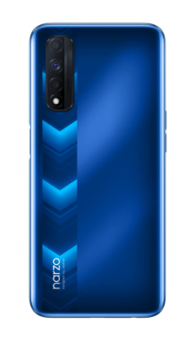
1. Hardware Components of Realme Narzo 30 4G
Hardware Features of this Smartphone Facilitate the Process of Edge Computing on It.
Key Hardware Features of the Device

- Processor/CPU and GPU

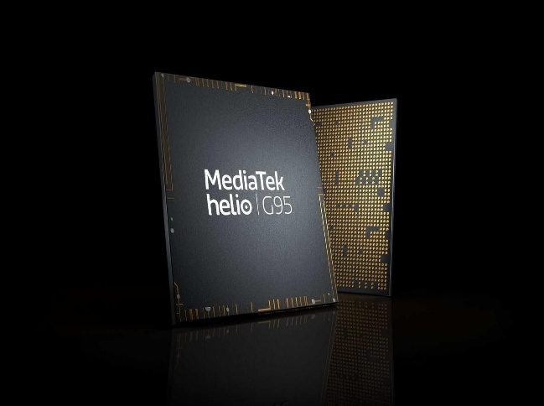
  - MediaTek Helio G95 Octa-core processor
  - Graphics Processing Unit (GPU) of Mali-G76
  - Fast Data Processing and Multitasking Support

- Memory
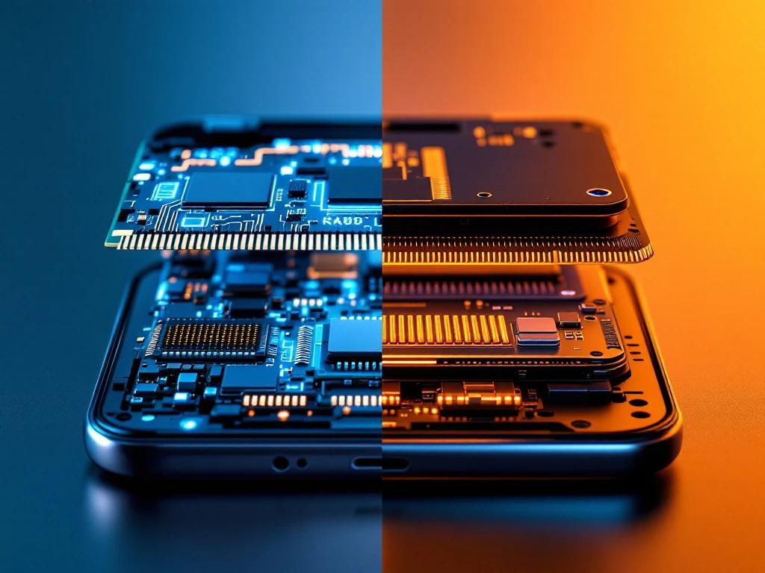
  - 4 GB/6GB RAM Memory
  - 64GB/128GB Storage

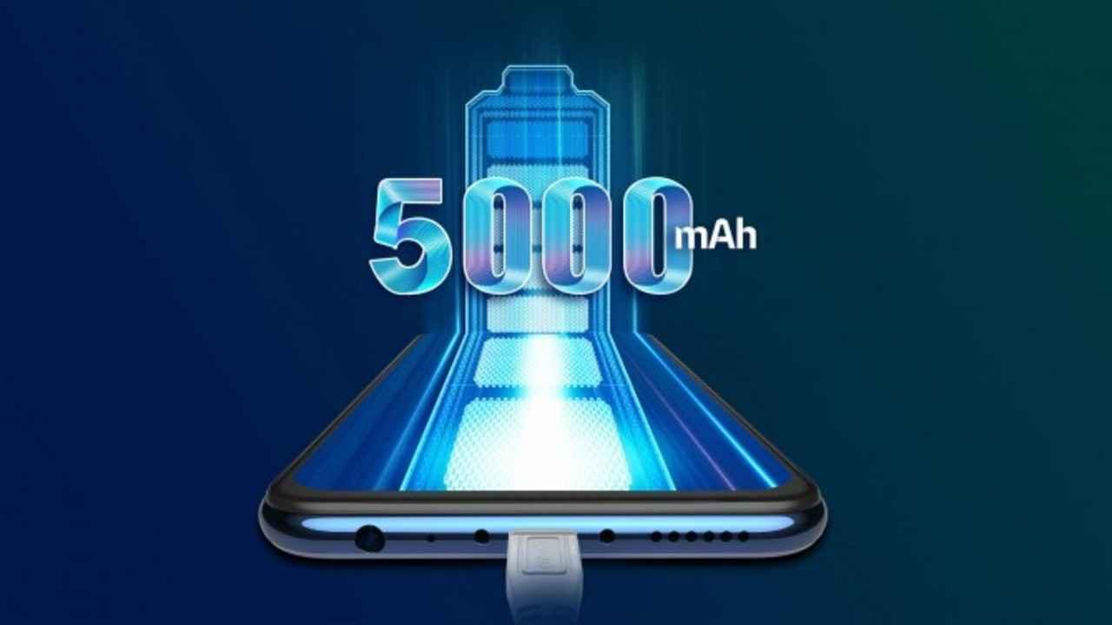
- Battery

  - Battery Capacity of 5000mAh
  - High Capacity Battery Supports Long IoT Tasks

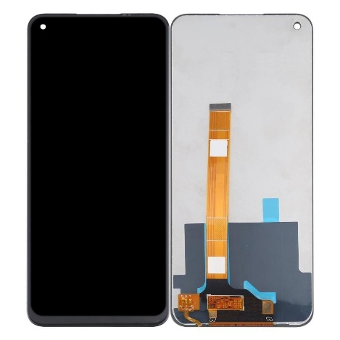
- Display/Input

  - 6.5 inch full HD display with touchscreen support
  - Used for Inputting by Touch

- Camera System
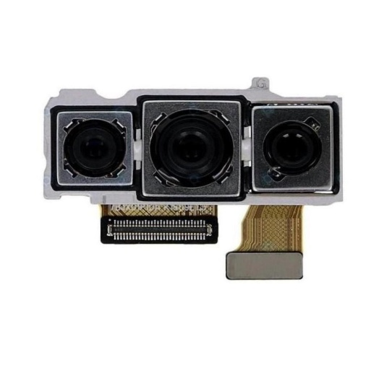

  - 48MP Triple Rear Camera
  - 16MP Front Camera
  - Can Be Used For Image-Based IoT Applications

- Connectivity

  - Wi-Fi and Bluetooth connectivity
  - Also has 4G LTE Connectivity

These hardware features make the phone capable of efficient data collection, processing, and transmission, thus making it ideal as an edge device.

2. Operating System (OS)
- The operating system of Realme Narzo 30 4G includes:
  - Android 11
  - Realme UI (custom interface for Android)

- OS Functionality in IoT Devices
  - Resources Management

- Manages CPU, memory, and power consumption
  - Application Execution

- Executes IoT applications such as smart home controls and health monitoring applications
  - Security Measures

- Includes permission, encryption, and biometric security features
  - Network Services Management

- Manages networks such as Wi-Fi, Bluetooth, and mobile data
  - Sensors Access

- Provides APIs for accessing sensors information ,
The operating system guarantees efficient communication between hardware components, sensors, and IoT applications.

3. Sensors in Realme Narzo 30 4G
The sensors will assist in collecting real-world data that is crucial in IoT technology.
Available Sensors & Functions

Accelerometer
- Detects motion and orientation
- Used in fitness tracking

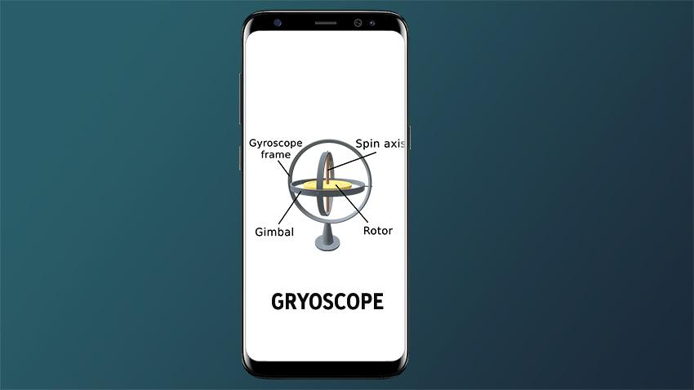
Gyroscope
- Measures rotation
- Used in gaming/navigation

Proximity Sensor
- Detects nearby objects
- Turns off screen during calls

Ambient Light Sensor
- Adjusts screen brightness

Fingerprint Scanner
- Provides authentication

Magnetometer (Compass)
- Direction detection
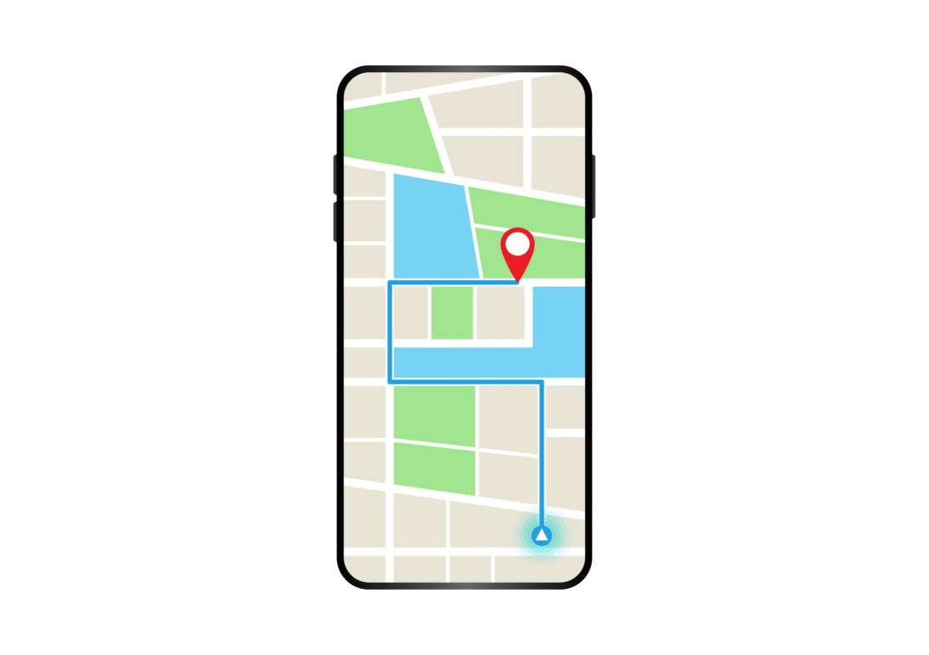
GPS
- Location tracking
The above-listed sensors give the smartphone the ability to detect environmental information and user interactions. Therefore, it is a good IoT edge device.
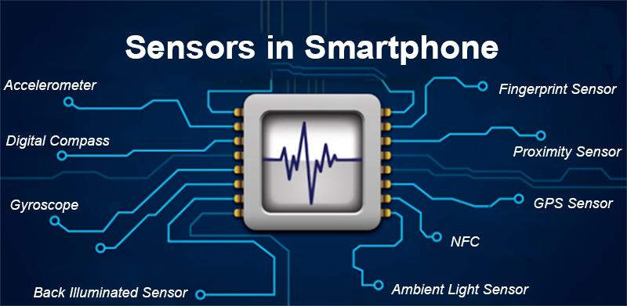
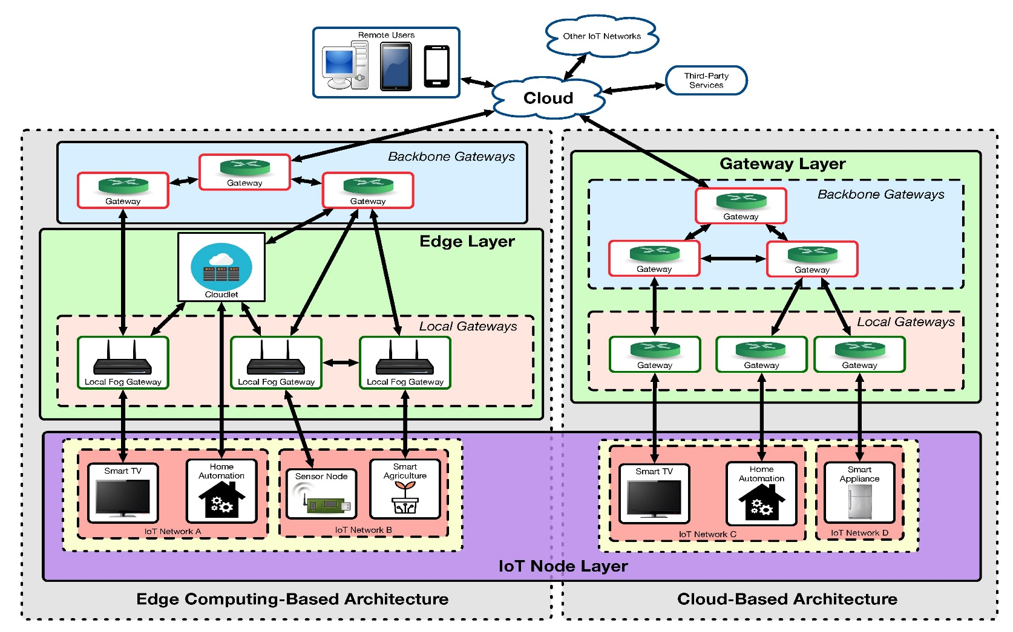
4. Realme Narzo 30 4G as an IoT Edge Device

This smartphone fulfills all IoT edge device requirements
Functions of an Edge Device
- Data collection
- Using sensors to collect environmental data
- Data processing
- Local processing of the collected data by using Helio G95 processor
- Communication
- Transmission of collected data through Wi-Fi, Bluetooth, and mobile network connections
- Decision making
- Can be used to control devices such as Smart Home appliances

5. Conclusion
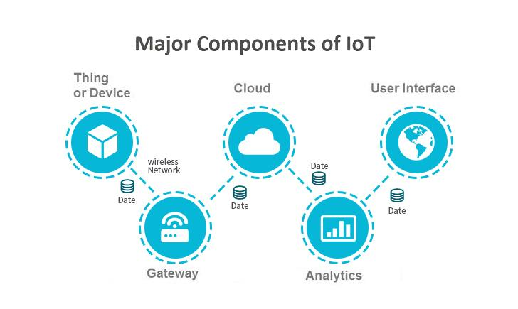
The Realme Narzo 30 4G can serve as an effective IoT edge computing device owing to its advanced hardware components, optimized operating system, and numerous sensors.
Hardware – Processing and Connectivity
Operating System – Resource Management and Security
Sensors – Data Collection
All of these features ensure that the device serves as a reliable IoT edge computing system.

